**CREATION D’UNE IMAGE ECHANTIONNER DE N PAS**

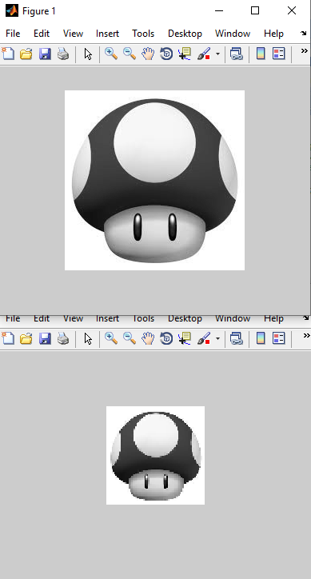

clc

clear all

close all

I=imread('pic.bmp');

[L,C]=size (I); %L=Ligne,C=Colone

pas=3;

ii=0;

for i=1:pas:L;

ii=ii+1;

jj=0;

for j=1:pas:C;

jj=jj+1;

Im(ii,jj)=I(i,j);

end

end

figure(1), imshow(I);

figure(2), imshow(Im);

imwrite(Im,'pic_echant.bmp','BMP');

size(I) % 225 225

size(Im) % 75 75